4. Git HandsOn

Please follow the instructions to complete the hands-on. Each instruction expect a command for the Git Bash.
- Verify if master is in clean state.
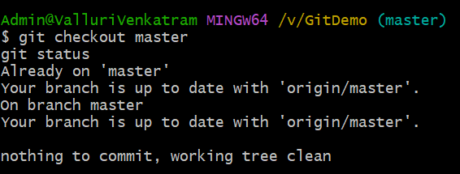
- Create a branch “GitWork”. Add a file “hello.xml”.
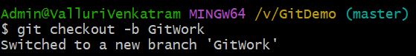
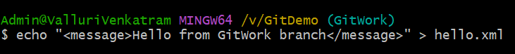
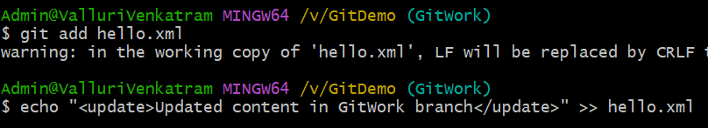
- Update the content of “hello.xml” and observe the status

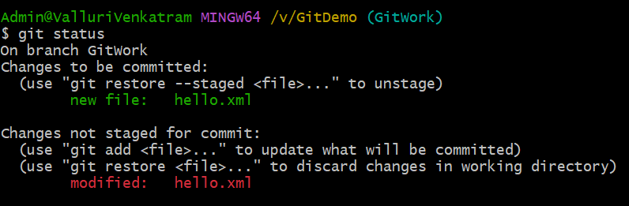
- Commit the changes to reflect in the branch
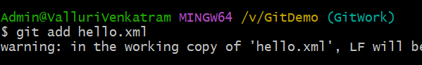
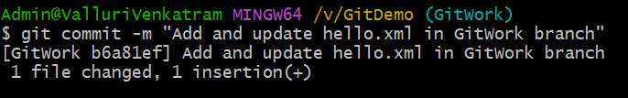
- Switch to master.
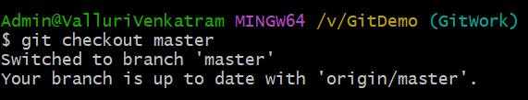
- Add a file “hello.xml” to the master and add some different content than previous.
- Commit the changes to the master
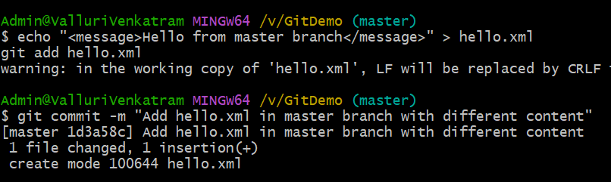
- Observe the log by executing “git log –oneline –graph –decorate –all”
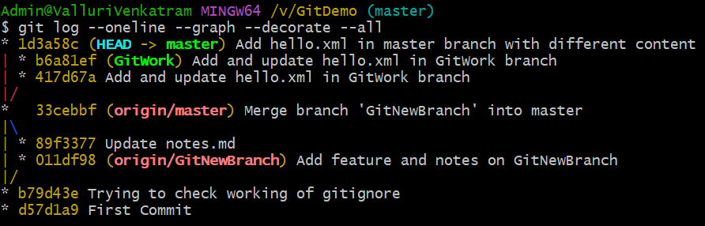
- Check the differences with Git diff tool
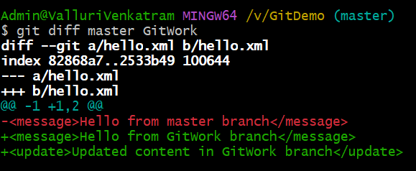
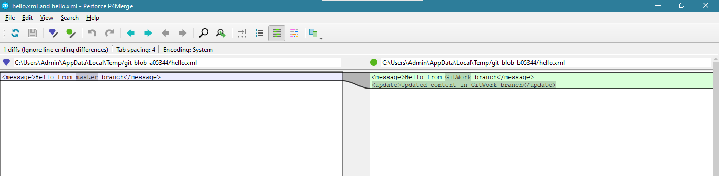
- For better visualization, use P4Merge tool to list out all the differences between master and branch

- Merge the bran to the master
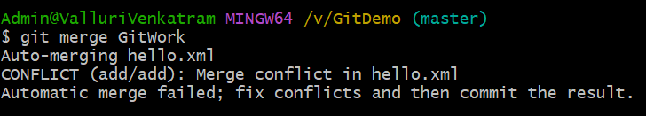
- Observe the git mark up.
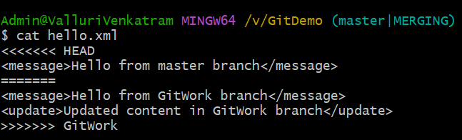

- Use 3-way merge tool to resolve the conflict
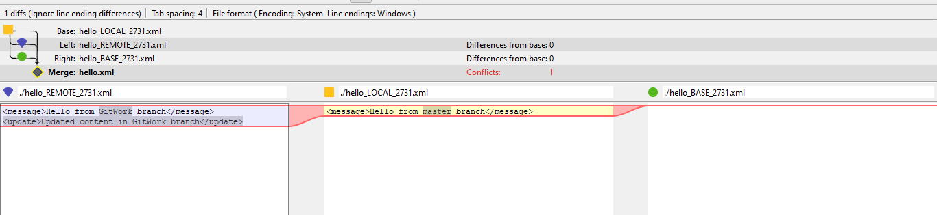
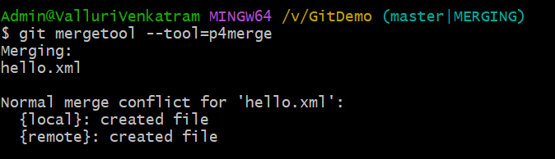
- Commit the changes to the master, once done with conflict
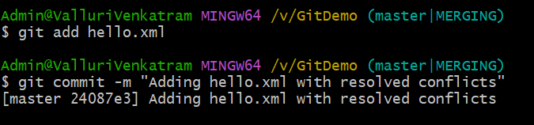

- Observe the git status and add backup file to the .gitignore file.
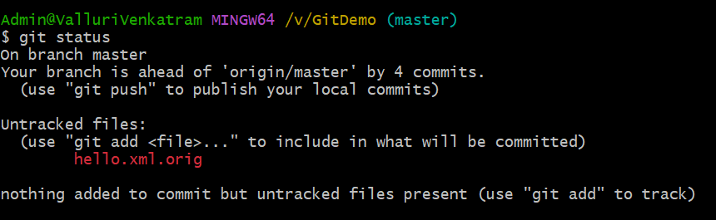
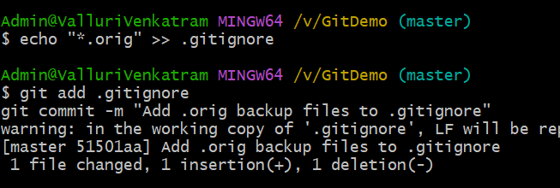
- Commit the changes to the .gitignore

- List out all the available branches
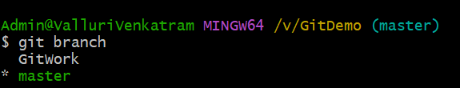

- Delete the branch, which merge to master.
- Observe the log by executing “git log –oneline –graph –decorate”
